You are given an integer n, which indicates that there are n courses labeled from 1 to n. You are also given an array relations where relations[i] = [prevCoursei, nextCoursei], representing a prerequisite relationship between course prevCoursei and course nextCoursei: course prevCoursei has to be taken before course nextCoursei.

In one semester, you can take **any number** of courses as long as you have taken all the prerequisites in the **previous** semester for the courses you are taking.

Return *the* ***minimum*** *number of semesters needed to take all courses*. If there is no way to take all the courses, return -1.

**Example 1:**

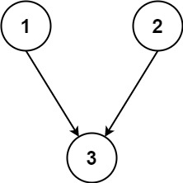

Input: n = 3, relations = [[1,3],[2,3]]  
Output: 2  
Explanation: The figure above represents the given graph.  
In the first semester, you can take courses 1 and 2.  
In the second semester, you can take course 3.

**Example 2:**

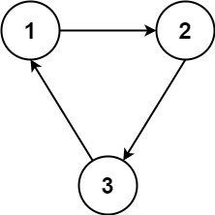

Input: n = 3, relations = [[1,2],[2,3],[3,1]]  
Output: -1  
Explanation: No course can be studied because they are prerequisites of each other.

**Constraints:**

* 1 <= n <= 5000
* 1 <= relations.length <= 5000
* relations[i].length == 2
* 1 <= prevCoursei, nextCoursei <= n
* prevCoursei != nextCoursei
* All the pairs [prevCoursei, nextCoursei] are **unique**.